Vesta – Specialist Family Support CIC
e-mail: info@vestasfs.org
tel. 07545075093
www.vestasfs.org

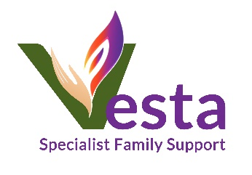
Please send completed form to referrals.1@vestasfs.cjsm.net or protect document with a password and send it to info@vestasfs.org
and send the password to a mobile number 07545075093

Referral form

REFERER details
Date of referral: |  | Organisation’s name:
Name of person making referral: |  | Position:
Telephone number |  | E-mail address:

CLIENT details
Name of CLIENT:
Support type you are requesting:
DOB:
Address:
Nationality:

Gender:

Client contact number and best time to call:

Is client aware of the referral:

PARTNER details
Name:
DOB:
Address:
Nationality:
Gender:

Relationship type (spouse/partner/ex-partner)

CHILDREN details
Name:
DOB:
Gender:

Relationship to client, parental responsibility?
Social Care involvement - type
Name of social worker

REASONS FOR REFERRAL

IS THERE ANYTHING ELSE THAT YOU THINK WE SHOULD KNOW ABOUT THE CLIENT? (evidence of risk towards professionals, medical problems, any vulnerabilities?)

WHAT OUTCOMES WOULD YOU LIKE TO ACHIEVE FOR THE CLIENT THROUGH THIS INTERVENTION?

We would like to understand your needs in relation to your work with Polish clients. It will help us to shape our future projects and to obtain funding so we can continue to deliver free services. Please answer the below questions:

1. What are the most common problems that Polish families have in your area?

2. What difficulties do you face when working with them?

3. How many Polish families did you work with in the past 12 months?

